**Prerequisites**

Project Name: Trip based modeling of fuel consumptio in modern fleet vehicles using machine learning.

: PNT2022TMID28314

Team ID

Anaconda Navigator and all the packages required are installed by all the team members. Software requirements are satisfied.

# Anaconda Navigator Installation

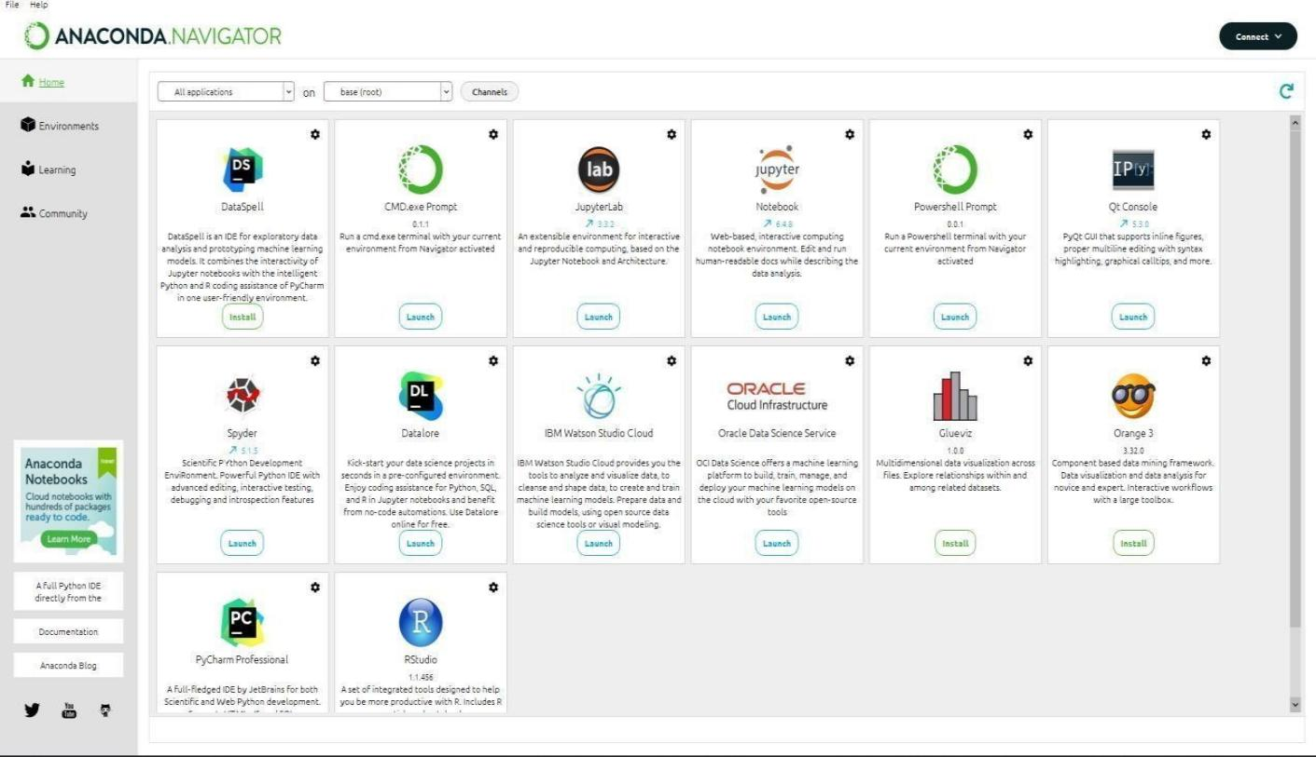

Anaconda Navigator is a free and open-source distribution of the Python and R programming languages for data science and machine learning related applications. It can be installed on Windows, Linux, and macOS. Conda is an open-source, cross-platform, package management system. Anaconda comes with so very nice tools like JupyterLab, Jupyter Notebook, QtConsole, Spyder, Glueviz, Orange, Rstudio, Visual Studio Code. For this project, we will be using Jupiter notebook and spyder.

# Packages Installation

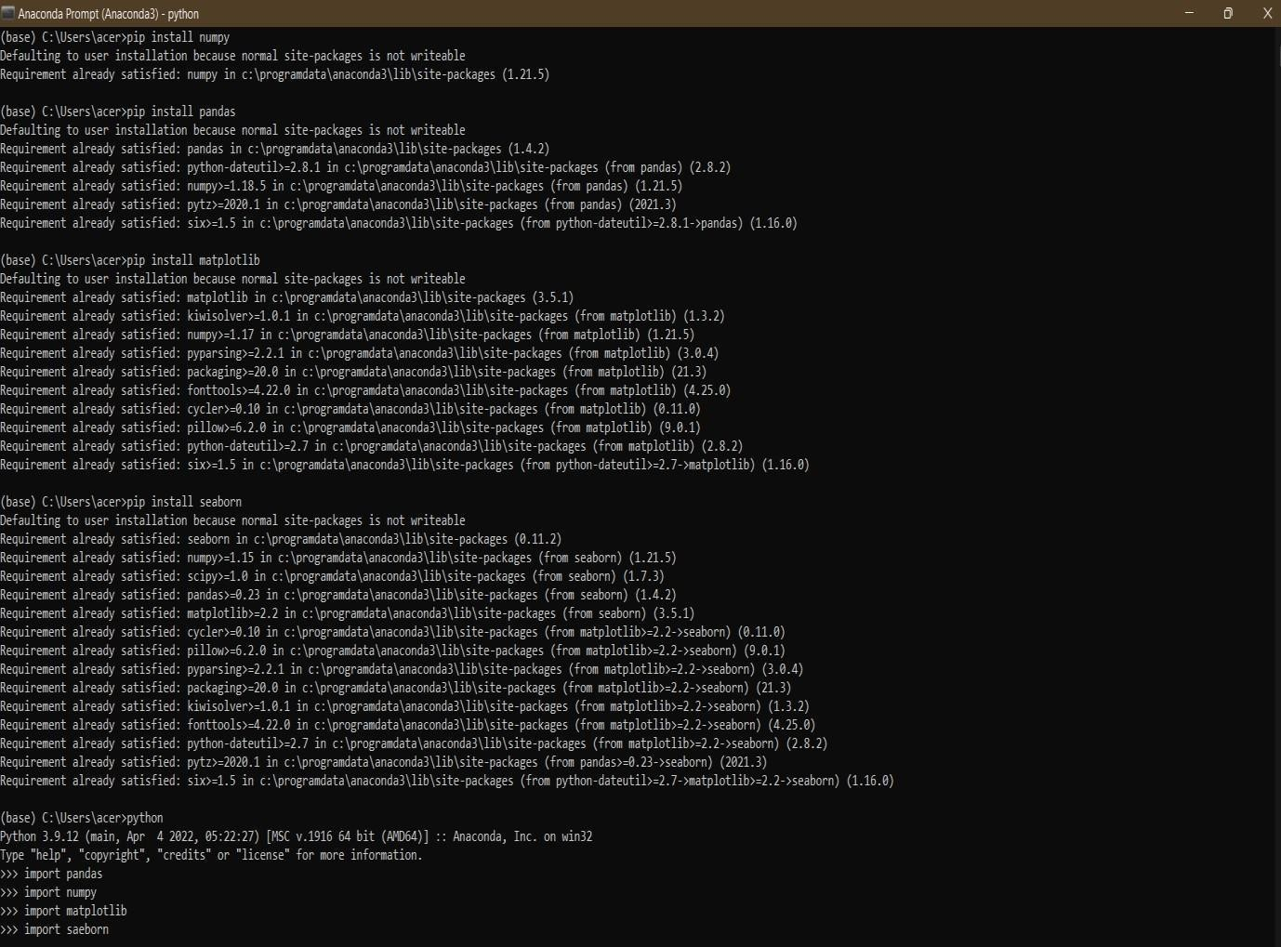

Packages installed are:

1. Pandas 5. Tensorflow
2. Numpy 6. Keras
3. Matplotlib 7. Opencv
4. Seaborn 8. Flask

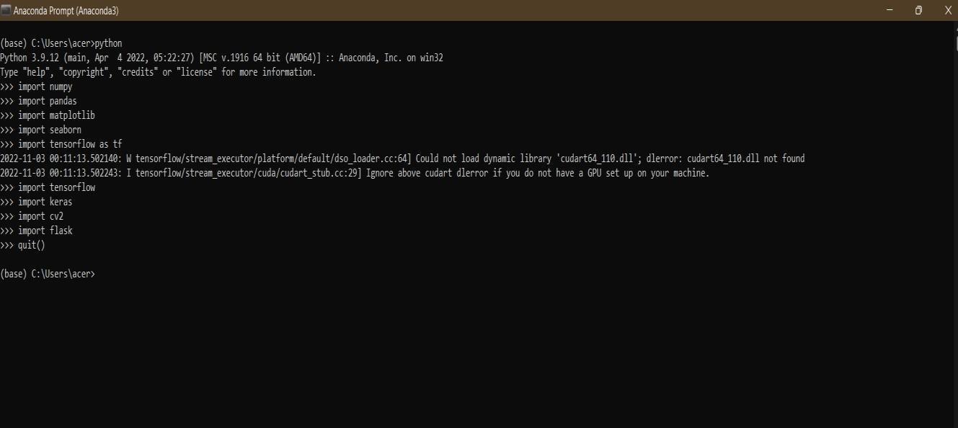

# Jupyter Notebook

